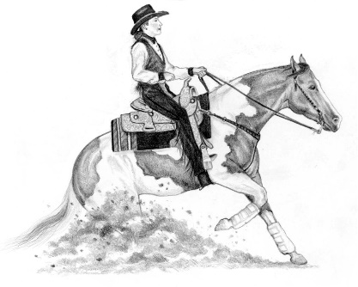
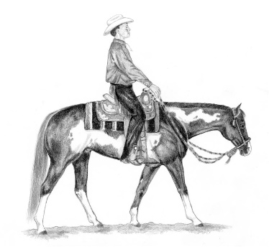
1-603-926-6762 for room rate of $119.00 plus tax. CUT-OFF date of 1/28/24 mention NE Paint Horse for rate.

Cash Bar at 6:00 P.M.
Dinner at 7:00 P.M.
Awards Celebration
Dancing
Scholarship Award
Silent Auction
Brown Bag Raffle
Membership Drive
Door Prize
Please bring a donation for the raffle
Zina Slade Scholarship
Ashworth by the Sea
Room Reservations
New England Paint Horse Club
2023 Annual Awards Banquet
February 17, 2024
Ashworth by the Sea, Hampton, NH
Reservation Form for 2023
Tables seat 8. Please submit payment and list of names for your table in one envelope. If you have less than 8 people, be sure to include payment and list of names you wish to sit with, others will be seated with you to make a table of 8.
# of Adult Buffet dinners @ $50.00 __________ (13 & Over)
Names for Table Reservation (8 per table): ______________________________
_________________________________________________________________
_________________________________________________________________
# of Child Buffet dinners @ $25.00 __________ (12 & Under)
Reservations must be received by February 10, 2024 – Sorry no walk-ins!
Make checks payable to: NEPHC
Mail this form with payment to: Karen Roy ~ 27 Grove Avenue ~ Salem, NH 03079 or Paypal direct to info@nephc.com

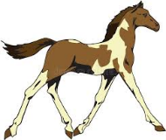
Please make advance arrangements for your award(s) to be picked up if you cannot attend. We cannot ship awards and ribbons.

